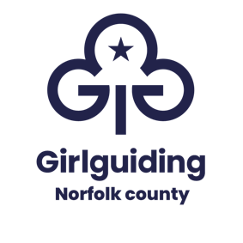
UNIT, DISTRICT AND DIVISION
BANK ACCOUNT DETAILS

Account name
District
Division
Bank name
Bank address
Sort code
Account number
Signatories – please include all authorised signatories:
Signatory 1
Name
Address

Signatory 2
Name
Address

Signatory 3
Name
Address

Signatory 4
Name
Address

Contact:
Name
Address

This information will be processed by Girlguiding Norfolk County in accordance with General Data Protection Requirements. The data will only be used for the purpose of accounting records and it will not be shared with other organisations or kept for longer than necessary for this purpose. Full details are included in the Girlguiding Norfolk County Privacy Notice available on request.

Units - please return a copy of the completed form to your district commissioner
Districts - please return a copy of the completed form to your division commissioner

Divisions - please return a copy of the completed form to the county treasurer – treasurer@girlguidingnorfolk.org.uk

